Minutes
E.E. Oliver School Council
E. E. Oliver Parents’ Council Society
Date: May 31, 2018
Location: E.E. Oliver Elementary School
Time: 7:00 pm –8:00 pm

Current Members: Chair/President – Christy Barlund Parents, Teachers, Community Members – refer to attendance sheet
Vice Chair/Vice-President – Carmen Enns Fundraising Chair – Talya Wald (Notice of Absence)
Secretary – Cindy Doll Peace River School Division Representative – Robyn Robertson
Treasurer – Leanne Stucklschwaiger
Principal – Elizabeth Green

Call To Order School Council Meeting – __7:05pm

1. Introductions (if necessary)
2. Approval of March 22, 2018 and April 19, 2018 minutes – Motioned by Leanne/Seconded by Jeanne
3. Approval of May 31, 2018 Agenda – Motioned by Carmen/Seconded by Jeanne
4. Old Business:
- March newsletter submission (attached)
http://www.eeoliverelementary.ca/documents/newsletters/March%20Newsletter.pdf
will try to continue this on a monthly basis to increase awareness. Sept 20th will be the council meeting in the new year as BRAG night should be the 18th of September.
- Water in upper level playground
email from ToF Mr. Leatham April 23rd 2018
Water issues seem to happen every year on that playground, might’ve dried up a little faster then usual this year. Has been going on for a lot longer than just this year, will try not to let it slide with ToF council. Try to find old supporting documents in ‘archives’ of minutes
- Discussion about decorative learning ideas for walls/floors/doors
Will forward ideas on to Mrs Green to see if teachers would be interested, outside courtyard space not used terribly much.
5. School Board Trustee Report: - Robyn Robertson
Recently had the presentation for long time service awards (5-40years). 8 new school busses to replace ones 11 years and older. The ongoing home schooling committee is looking at ways that PRSD engages and supports families by increasing communication. Inclusive Education initiatives, services and supports for students with complex and special needs, PRSD’s focus on literacy, wellness initiatives, technology integration and employee contract obligations. Operational dollars provide safe and caring learning environments through physical upgrades, maintenance on schools and safe transportation for students. Preliminary budget has been approved, EEO will get a roofing upgrade. Trustees are focused on advocacy for increased mental health and addictions support in schools –discussion about retention of professionals in the north. Christy will look into collaboration with GPRC’s Fairview mental health councilor and forward contact info to Mrs. Green if possible.
6. Principal Report: – Elizabeth Green
Will be participating in ToF and MD mock emergency exercise the morning of June 14th so don’t be alarmed if more than normal vehicles present at EEO or at the Firehall. Grade 5 & 6 students will be volunteering to dramatize the exercise as ‘evacuees’. Classroom blinds, library rug and security cameras have been approved and will be installed this summer from the pooled funds account. ECS and Stepping Forward will be instructed by the same individual this coming year (Ms. Rowe) as it was this year (Ms Lazorko) – will be focusing on play based learning with differentiated instruction. Are looking into providing Out of School Care space (before and after school; 7:45am-8:30am and 3:30pm-5:30pm) in conjunction with Child’s World Day Care and finding the flexibility to offer the space for this programming in the school. Funding for iCoach has been increased to 1.5 and FNMI has been maintained). This coming Monday is a PD day and will be hosting a staff learning FNMI presentation which parent council is invited to attend (11am-noon and 1-2:30pm) (June 21 is National Aboriginal Day). June 15th will be celebrating the million minutes in the library. Grade 6 camping trip is still working on fundraising and would like the support of Parent Council to ensure that all students can participate.

7. New Business:
- Council of School Council meeting update – school council handbook
Conference was an excellent experience large focus on mental health initiatives, will be better prepared for next time as now we have a bit of context. Highly recommend going to it. PRSD board of trustees supported attendees with $800 per council but Christy had entire claim paid (registration, hotel and travel) as not all councils sent a representative.
- Round Table:
- NEXT MEETING: June 18 2018 5:30pm at the Butter Chicken (everyone pays for their own meal so quite informal)

10. Adjourn School Council Meeting: 8:05pm
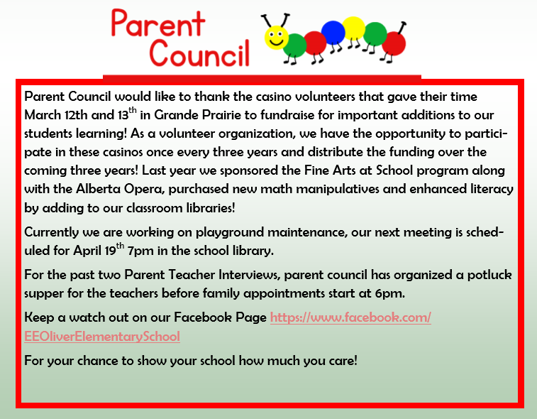
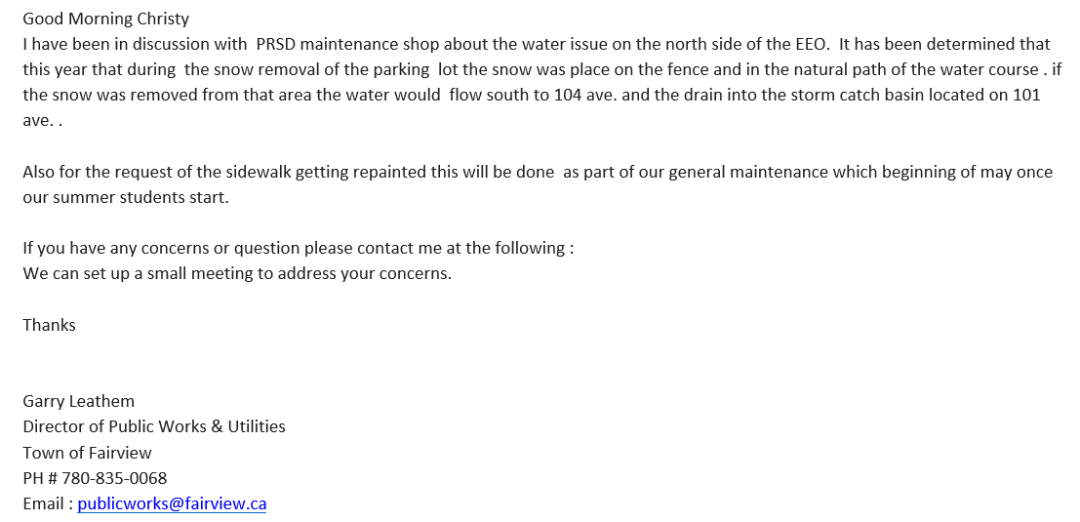

Call to Order Parent Council Meeting - 8:05pm

1. Approval of March 22 and April 19 minutes - Motioned by Leanne/Seconded by Jeanne
2. Approval of May 31, 2018 Agenda – add grade 6 camping trip to old business – Amended agenda motioned by Jeanne/Seconded by Carmen
3. Treasurer Report: Leanne Stucklschwaiger - no changes to report.
4. Old Business:
- EEO School South Playground – new gravel quotes/estimates
Mrs Green has submitted a work order to obtain quotes. There is ~$5500 in playground account to cover it.
- Grade 6 camping trip – $2384.50 was made by the basket raffle at Christmas time. Discussion about what the casino money is allotted to. Will get Talya to double check what we are allowed to spend casino money on.
Jeanne made a motion to make cheque for $2300 to cover field trip transportation costs to be divided as principal best sees fit from general account. Carmen seconded. Carried.

5. New Business:
- AGLC Distribution of Pooled Funds (attached)
  - Thank You notes for Casino volunteers – will get contact list from Talya.
6. Round Table
7. NEXT MEETING: June 18th 5:30pm at Butter Chicken restaurant
8. Adjourn School Council Meeting: 8:30pm

