E. E. Oliver Elementary School
“Engaged Learning for a Successful Future”

Annual Education Results Report
Three Year Education Plan
2020-2022

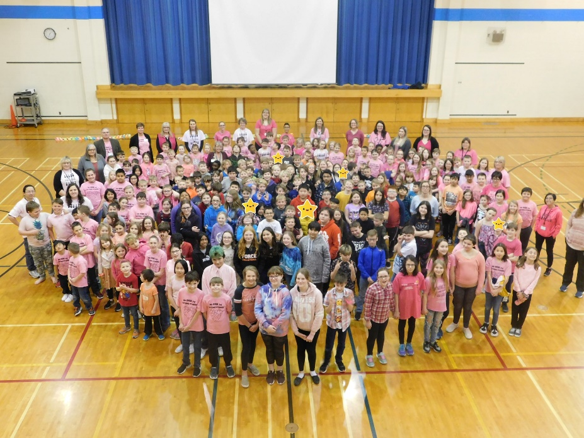

We are a proud member of the Peace River School Division #10

Accountability Statement:
Peace River School Division # 10 subscribes to a combined Annual Education Results Report (AERR) and Three Year Education Plan (3 YEP).

This report is a summary of E.E. Oliver School’s achievements for the 2019-2020 school year and a Three Year Education Plan for 2020 – 2023 beginning in the 2020 school year. The school has used the results reported in the document to develop the Education Plan and is committed to implementing the strategies contained within it to improve student learning and results.

Vision Statement:
At E.E. Oliver Elementary School we will be an inclusive, inspiring, learning focused community that equips students with knowledge and skills to ensure a successful future.

Mission:
The EEO community will provide an atmosphere where there are high expectations for learning, using a holistic, flexible, and responsive plan with a future oriented mindset.

At E.E. Oliver we value:

Excellence: to strive for the highest quality of one’s ability. Achievement: to set and attain a specific goal or purpose. Growth: to improve and change for a positive purpose.
Leadership: to promote, guide and demonstrate a positive and caring direction with integrity.
Empathy: to demonstrate sympathetic understanding of another.
Sportsmanship: to demonstrate a positive attitude that promotes safety and self-esteem.

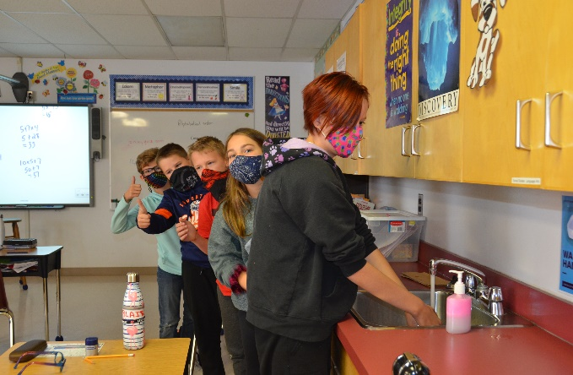

School Profile:

E. E. Oliver Elementary School is located in the heart of the Peace. It is a familiar landmark within the town of Fairview. From the moment its doors opened in 1959, E.E. Oliver became and remains an active partner in the Fairview community. The school was named after a prominent educator in Fairview, Mr. Eli Elmer ‘Gibby’ Oliver. The school has always maintained high expectations and standards for both its students and staff. Over the years E. E. Oliver has provided for the educational, recreational and social needs of thousands of people.

Our school provides for the educational needs of approximately 228 students from Stepping Forward and Kindergarten to Grade 6. The Stepping Forward Program offers an early childhood curriculum for young children who may need early intervention programs. Approximately half of the students of the school live in town and either walk to school or ride the cross-town bus. The remainder of the student body is bused in from the rural areas surrounding Fairview.

Stepping Forward, ECS | 28
Grade 1 | 27
Grade 2 | 30
Grade 3 | 29
Grade 4 | 34
Grade 5 | 33
Grade 6 | 31
On line Learners | 16

E. E. Oliver Elementary School is a child-centered school and we are very fortunate to have such a capable and caring staff. This dedicated group of professionals continuously strives to provide programs and activities that meet the needs of the whole child; the body and the mind. In addition to a balanced academic program, the school promotes a healthy lifestyle by offering daily physical education classes and encourages healthy eating through its Breakfast Program and Wellness Committee. Prior to COVID, E. E. Oliver regularly invited professional touring groups and community leaders into the school to enhance and promote the students’ exposure and appreciation of music, drama and the arts in general.

E.E. Oliver Elementary School enjoys a close working relationship with our School Council and a number of agencies within the Peace River School Division. Social workers, mental health specialists and counselors are some of the outside agencies that are active partners with the school community. We also have a Family School Liaison Worker stationed at the school to address social development problems. E. E. Oliver also works closely with the Northwest Alberta Child and Family Services Authority and Peace Collaborative Services as mental health services are in high demand for students in the north. We strive to ensure that our students are safe and supported in our school.

The school has a number of professional learning teams that meet, on a regular basis, to work together on improving their teaching practices. The Provincial Achievement Tests, Student Learning Assessments and parent/student satisfaction surveys are analyzed by the staff to set the goals for the school’s education plans.

Like all sectors in the province of Alberta in 2019, Fairview has been challenged with the impacts of the economic downturn on the families and community we serve as well as changing requirements of the Alberta Government to strive for more innovative opportunities.

Engaged Learning for a Successful Future… that is E. E. Oliver Elementary School!
Combined May 2020 Accountability Pillar Overall Summary
Measure Category | Measure | E E Oliver Elem School |  |  | Alberta |  |  | Measure Evaluation
 |  | Current Result | Prev Year Result | Prev 3 Year Average | Current Result | Prev Year Result | Prev 3 Year Average | Achievement | Improvement | Overall
Safe and Caring Schools | Safe and Caring | 90.9 | 96.1 | 89.2 | 89.4 | 89.0 | 89.2 | Very High | Maintained | Excellent
Student Learning Opportunities | Program of Studies | 88.4 | 96.6 | 91.2 | 82.4 | 82.2 | 82.0 | Very High | Maintained | Excellent
 | Education Quality | 93.9 | 97.7 | 95.4 | 90.3 | 90.2 | 90.1 | Very High | Maintained | Excellent
 | Drop Out Rate | n/a | n/a | n/a | 2.7 | 2.6 | 2.7 | n/a | n/a | n/a
 | High School Completion Rate (3 yr) | n/a | n/a | n/a | 79.7 | 79.1 | 78.4 | n/a | n/a | n/a
Student Learning Achievement (Grades K-9) | PAT: Acceptable | n/a | 75.5 | 75.4 | n/a | 73.8 | 73.6 | n/a | n/a | n/a
 | PAT: Excellence | n/a | 7.4 | 10.8 | n/a | 20.6 | 20.0 | n/a | n/a | n/a
Student Learning Achievement (Grades 10-12) | Diploma: Acceptable | n/a | n/a | n/a | n/a | 83.6 | 83.4 | n/a | n/a | n/a
 | Diploma: Excellence | n/a | n/a | n/a | n/a | 24.0 | 23.5 | n/a | n/a | n/a
 | Diploma Exam Participation Rate (4+ Exams) | n/a | n/a | n/a | 56.4 | 56.3 | 55.6 | n/a | n/a | n/a
 | Rutherford Scholarship Eligibility Rate | n/a | n/a | n/a | 66.6 | 64.8 | 63.5 | n/a | n/a | n/a
Preparation for Lifelong Learning, World of Work, Citizenship | Transition Rate (6 yr) | n/a | n/a | n/a | 60.1 | 59.0 | 58.5 | n/a | n/a | n/a
 | Work Preparation | 82.0 | 100.0 | 88.9 | 84.1 | 83.0 | 82.7 | High | Maintained | Good
 | Citizenship | 86.0 | 93.4 | 86.3 | 83.3 | 82.9 | 83.2 | Very High | Maintained | Excellent
Parental Involvement | Parental Involvement | 85.4 | 92.0 | 81.7 | 81.8 | 81.3 | 81.2 | Very High | Maintained | Excellent
Continuous Improvement | School Improvement | 92.5 | 95.8 | 88.7 | 81.5 | 81.0 | 80.9 | Very High | Improved | Excellent

Notes:
- Data values have been suppressed where the number of respondents/students is fewer than 6. Suppression is marked with an asterisk (*).
- Overall evaluations can only be calculated if both improvement and achievement evaluations are available.
- Student participation in the survey was impacted between 2014 and 2017 due to the number of students responding through the OurSCHOOL/TTFM (Tell Them From Me) survey tool.
- Aggregated PAT results are based upon a weighted average of percent meeting standards (Acceptable, Excellence). The weights are the number of students enrolled in each course. Courses included: English Language Arts (Grades 6, 9, 9 KAE), Français (6eet 9e année), French Language Arts (6e et 9e année), Mathematics (Grades 6, 9, 9 KAE), Science (Grades 6, 9, 9 KAE), Social Studies (Grades 6, 9, 9 KAE).
- Participation in Provincial Achievement Tests was impacted by the fires in May to June 2016 and May to June 2019. Caution should be used when interpreting trends over time for the province and those school authorities affected by these events.
- Aggregated Diploma results are a weighted average of percent meeting standards (Acceptable, Excellence) on Diploma Examinations. The weights are the number of students writing the Diploma Examination for each course. Courses included: English Language Arts 30-1, English Language Arts 30-2, French Language Arts 30-1, Français 30-1, Mathematics 30-1, Mathematics 30-2, Chemistry 30, Physics 30, Biology 30, Science 30, Social Studies 30-1, Social Studies 30-2.
- Participation in Diploma Examinations was impacted by the fires in May to June 2016 and May to June 2019. Caution should be used when interpreting trends over time for the province and those school authorities affected by these events.
- Weighting of school-awarded marks in diploma courses increased from 50% to 70% in the 2015/16 school year. Caution should be used when interpreting trends over time.
- 2016 results for the 3-year High School Completion and Diploma Examination Participation Rates have been adjusted to reflect the correction of the Grade 10 cohort.
- Improvement evaluations are not calculated for school and school authority Drop Out and Rutherford Scholarship Eligibility rates. Starting in 2019, an updated methodology was applied to more accurately attribute results in cases where students receive programming from more than one provider within a school year. Caution should be used when interpreting school and school authority

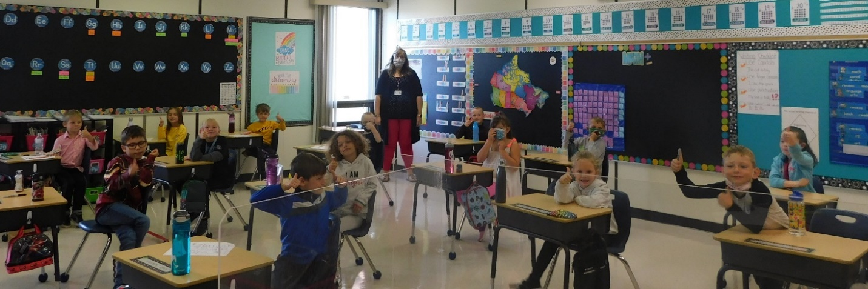

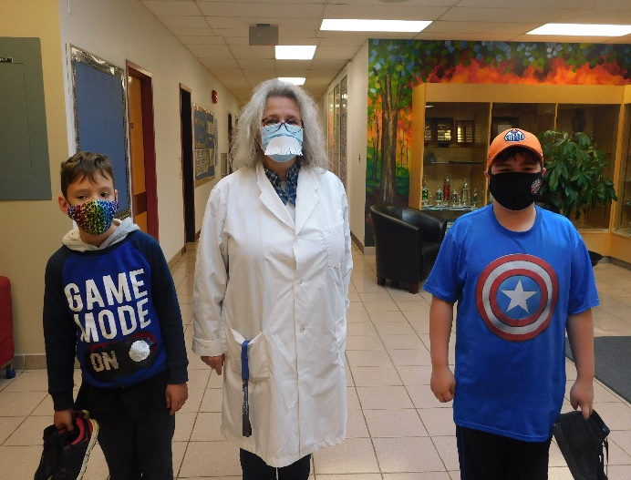
Measure Evaluation Reference
Achievement Evaluation
Achievement evaluation is based upon a comparison of Current Year data to a set of standards which remain consistent over time. The Standards are calculated by taking the 3 year average of baseline data for each measure across all school jurisdictions and calculating the 5th, 25th, 75th and 95th percentiles. Once calculated, these standards remain in place from year to year to allow for consistent planning and evaluation.
The table below shows the range of values defining the 5 achievement evaluation levels for each measure.
Measure | Very Low | Low | Intermediate | High | Very High
Safe and Caring | 0.00 - 77.62 | 77.62 - 81.05 | 81.05 - 84.50 | 84.50 - 88.03 | 88.03 - 100.00
Program of Studies | 0.00 - 66.31 | 66.31 - 72.65 | 72.65 - 78.43 | 78.43 - 81.59 | 81.59 - 100.00
Education Quality | 0.00 - 80.94 | 80.94 - 84.23 | 84.23 - 87.23 | 87.23 - 89.60 | 89.60 - 100.00
Drop Out Rate | 100.00 - 9.40 | 9.40 - 6.90 | 6.90 - 4.27 | 4.27 - 2.79 | 2.79 - 0.00
High School Completion Rate (3 yr) | 0.00 - 57.03 | 57.03 - 62.36 | 62.36 - 73.88 | 73.88 - 81.79 | 81.79 - 100.00
PAT: Acceptable | 0.00 - 66.07 | 66.07 - 70.32 | 70.32 - 79.81 | 79.81 - 84.64 | 84.64 - 100.00
PAT: Excellence | 0.00 - 9.97 | 9.97 - 13.44 | 13.44 - 19.56 | 19.56 - 25.83 | 25.83 - 100.00
Diploma: Acceptable | 0.00 - 71.45 | 71.45 - 78.34 | 78.34 - 84.76 | 84.76 - 87.95 | 87.95 - 100.00
Diploma: Excellence | 0.00 - 9.55 | 9.55 - 12.59 | 12.59 - 19.38 | 19.38 - 23.20 | 23.20 - 100.00
Diploma Exam Participation Rate (4+ Exams) | 0.00 - 31.10 | 31.10 - 44.11 | 44.11 - 55.78 | 55.78 - 65.99 | 65.99 - 100.00
Transition Rate (6 yr) | 0.00 - 39.80 | 39.80 - 46.94 | 46.94 - 56.15 | 56.15 - 68.34 | 68.34 - 100.00
Work Preparation | 0.00 - 66.92 | 66.92 - 72.78 | 72.78 - 77.78 | 77.78 - 86.13 | 86.13 - 100.00
Citizenship | 0.00 - 66.30 | 66.30 - 71.63 | 71.63 - 77.50 | 77.50 - 81.08 | 81.08 - 100.00
Parental Involvement | 0.00 - 70.76 | 70.76 - 74.58 | 74.58 - 78.50 | 78.50 - 82.30 | 82.30 - 100.00
School Improvement | 0.00 - 65.25 | 65.25 - 70.85 | 70.85 - 76.28 | 76.28 - 80.41 | 80.41 - 100.00

Notes:
- For all measures except Drop Out Rate: The range of values at each evaluation level is interpreted as greater than or equal to the lower value, and less than the higher value. For the Very High evaluation level, values range from greater than or equal to the lower value to 100%.
- Drop Out Rate measure: As "Drop Out Rate" is inverse to most measures (i.e. lower values are "better"), the range of values at each evaluation level is interpreted as greater than the lower value and less than or equal to the higher value. For the Very High evaluation level, values range from 0% to less than or equal to the higher value.

Improvement Table
For each jurisdiction, improvement evaluation consists of comparing the Current Year result for each measure with the previous three-year average. A chi-square statistical test is used to determine the significance of the improvement. This test takes into account the size of the jurisdiction in the calculation to make improvement evaluation fair across jurisdictions of different sizes.
The table below shows the definition of the 5 improvement evaluation levels based upon the chi-square result.
Evaluation Category | Chi-Square Range
Declined Significantly | 3.84 + (current < previous 3-year average)
Declined | 1.00 - 3.83 (current < previous 3-year average)
Maintained | less than 1.00
Improved | 1.00 - 3.83 (current > previous 3-year average)
Improved Significantly | 3.84 + (current > previous 3-year average)

Overall Evaluation Table
The overall evaluation combines the Achievement Evaluation and the Improvement Evaluation. The table below illustrates how the Achievement and Improvement evaluations are combined to get the overall evaluation.
 | Achievement
Improvement | Very High | High | Intermediate | Low | Very Low
Improved Significantly | Excellent | Good | Good | Good | Acceptable
Improved | Excellent | Good | Good | Acceptable | Issue
Maintained | Excellent | Good | Acceptable | Issue | Concern
Declined | Good | Acceptable | Issue | Issue | Concern
Declined Significantly | Acceptable | Issue | Issue | Concern | Concern

Category Evaluation
The category evaluation is an average of the Overall Evaluation of the measures that make up the category. For the purpose of the calculation, consider an Overall Evaluation of Excellent to be 2, Good to be 1, Acceptable to be 0, Issue to be -1, and Concern to be -2. The simple average (mean) of these values rounded to the nearest integer produces the Category Evaluation value. This is converted back to a colour using the same scale above (e.g. 2=Excellent, 1=Good, 0=Intermediate, -1=Issue, -2=Concern)

Outcome One: Alberta’s students are successful

Performance Measure | Results (in percentages) |  |  |  |  | Targets
 | 2016 | 2017 | 2018 | 2019 | 2020 | 2021 | 2022
Overall percentage of students in Grades 6 and 9 who achieved the acceptable standard on Provincial Achievement Tests (overall cohort results). | 67.6 | 83 | 75.5 | 85 | N/A | N/A | 86
Overall percentage of students in Grades 6 and 9 who achieved the standard of excellence on Provincial Achievement Tests (overall cohort results). | 7.4 | 17.6 | 7.4 | 10 | N/A | N/A | 11

Comment on Results
Due to COVID-19 restrictions, the spring 2020 Provincial Achievement Tests were cancelled.

This year we will continue to focus on core strands in Literacy and Numeracy, which should see increased results in Language Arts and Math.

Action Plan

- School-wide we will identify specific essential outcomes in core subject areas (literacy and numeracy) which are of concern.
Literacy Skills:
Reading: finding the main idea, inferencing, sequencing, comprehension, fluency, phonemic awareness, decoding
Writing: organizing, content/details/descriptors, sentence structure, conventions, learn to express themselves. (Narrative and Expository)
Numeracy Skills such as: basic facts and operations, multi-step problem solving, critical and creative thinking skills.

Strategies

- Focus teaching on specific essential outcomes in core subject areas.
- Employ Differentiated Instruction strategies to meet the needs of all students.
- Employ Balanced Literacy: The read aloud, guided reading, shared reading, independent reading and word study.
- Continue to provide teachers with literacy and numeracy resources/professional development.
- PLC meetings focus on strategies for increasing literacy and numeracy (2020-2021) skills in students through the development of best practices.
- Collaborative Response team meetings monthly to examine student performance/achievement data to inform instruction.
- Explore pre-assessments, differentiated assessment, formative/summative assessments, and the use of common, consistent rubrics to determine if students have achieved the desired outcomes.
- Use flexible groupings with a clear focus on literacy and numeracy skill acquirement.
- Employ guided reading and guided writing strategies to focus on specific essential outcomes. (Reader’s Workshop/Writer’s Workshop/Empowering Writers)
- Ensure 1 to 1 student access to devices, other technologies and to assistive technologies to support student learning.
- Teach Keyboarding as an essential skill.

Notes:
- Data values have been suppressed where the number of respondents/students is fewer than 6. Suppression is marked with an asterisk (*).
- Overall evaluations can only be calculated if both improvement and achievement evaluations are available.
- Aggregated PAT results are based upon a weighted average of percent meeting standards (Acceptable, Excellence). The weights are the number of students enrolled in each course. Courses included: English Language Arts (Grades 6, 9, 9 KAE); Français (Grades 6, 9); French Language Arts (Grades 6, 9); Mathematics (6, 9, 9 KAE); Science (Grades 6, 9, 9 KAE); and Social Studies (Grades 6, 9, 9 KAE).
- Participation in Provincial Achievement Tests was impacted by the flooding in June 2013 (Grade 9 only) and by the fires in May to June 2016. Caution should be used when interpreting trends over time for the province and those school authorities affected by these events.

Outcome One: Alberta’s students are successful (continued)

Performance Measure | Results (in percentages) |  |  |  |  | Targets
 | 2016 | 2017 | 2018 | 2019 | 2020 | 2021 | 2022
Percentage of teachers, parents and students who are satisfied that students model the characteristics of active citizenship. | 71.6 | 80.0 | 85.5 | 93.4 | 86.0 | 88 | 89
Percentage of teachers and parents who agree that students are taught attitudes and behaviours that will make them successful at work when they finish school. | 77.9 | 83.3 | 83.3 | 100 | 82.0 | 86 | 87

Comment on Results

Our results for the measure of students modelling characteristics of active citizenship as well as that students are taught attitudes and behaviours that make them successful at work have decreased, but they are in line with the results from 2018. Parent results were suppressed in 2019. In 2020 parent results did lower the average.

Action Plan

- Engage students in citizenship activities and/or projects, and communicate these initiatives to the wider community.
- Engage students in discussions of what qualities do active citizens demonstrate and make them successful at work.
- Highlight the qualities of active citizenship and work preparedness that are taught at elementary school level.
- Continue to provide advocacy mentorship opportunities for students with adults, peers, and older students within the school community within COVID regulations.
- Continue to educate, engage, and monitor students on the principles of responsible digital citizenship.
- Establish community partnerships to assist with global digital responsibilities.

Strategies

- Health/Social Studies teachers will define and highlight Citizenship activities which are happening at EE Oliver. (Foster Child, Charity Events (Terry Fox, Festival of Trees), Grand Buddies, Reading Buddies; Volunteering in Breakfast/Playground Monitors, AMA, Lunch Monitors, Milk Monitors, Peacemakers, PALS, Library Helpers, participating in Student Council, participating in events such as Orange T-shirt day, Pink Shirt Day, and First Nations, Metis and Inuit cultural activities). Grade 4-6 students will be expected to volunteer to achieve Citizenship Awards. **** Subject to COVID restrictions)
- Highlight these events as Citizenship activities on our Website, Newsletter, invite the press, school council
- All teachers highlight expectations regarding appropriate behavior around our school community and how it is also appropriate behavior for the workplace. (WITS)
- Continue to Implement Digital Literacy/Citizenship program. (e.g. Teluswise)
- Send monthly news articles and pictures to Fairview Post and to Communications Officer at PRSD. Adopt a Classroom Reporter Program and Student Council.
- Form a Positive Behaviour committee to explore how to best recognize the good work of our students and student groups. (eg. Citizenship Awards).
- Explore outside motivational speakers who focus on increasing positive relationships. (Positive Pen and Post It Board, bullying prevention programs, child protection programs)
- Communicate to students the definition of Citizenship and how we promote it at EE Oliver. Create a Citizenship bulletin board.
- Encourage an entrepreneurial spirit through our Students’ Union.
- Survey parents on how they feel we can improve various aspects of our school.
- Prior to parent survey going out, send home a Parent Information Package detailing how EEO is addressing each of the outcomes.

Notes:
- Data values have been suppressed where the number of respondents/students is fewer than 6. Suppression is marked with an asterisk (*).
- Student participation in the survey was impacted between 2014 and 2017 due to the number of students responding through the OurSCHOOL/TTFM (Tell Them From Me) survey tool.

Outcome Two: Alberta’s education system supports First Nations, Métis, and Inuit students’ success

(Results and evaluations for First Nations, Métis and Inuit measures are required for Public/Separate/Francophone schools only)
Performance Measure | Results (in percentages) |  |  |  |  | Targets
 | 2016 | 2017 | 2018 | 2019 | 2020 | 2021 | 2022
Overall percentage of self-identified FNMI students in Grades 6 and 9 who achieved the acceptable standard on Provincial Achievement Tests (overall cohort results). | * | * | 62.5 | 61.8 | N/A | N/A | 62
Overall percentage of self-identified FNMI students in Grades 6 and 9 who achieved the standard of excellence on Provincial Achievement Tests (overall cohort results). | * | * | 16.7 | 4.4 | N/A | N/A | 10
Overall percentage of self-identified FNMI students who achieved the acceptable standard on diploma examinations (overall results). | n/a | n/a | n/a | n/a | N/A | N/A | N/A
Overall percentage of self-identified FNMI students who achieved the standard of excellence on diploma examinations (overall results). | n/a | n/a | n/a | n/a | N/A | N/A | N/A

Comment on Results

Due to Covid-19 restrictions, the spring 2020 Provincial Achievement Tests were cancelled. EE Oliver continues to be committed to ensuring our Indigenous students receive a quality education which recognizes their unique culture.
Action Plan

- To improve the achievement of Indigenous students.
- To provide opportunities to learn and appreciate different cultures in our school community.
- Continue to focus on to improve/enhance the literacy/numeracy skills of Indigenous students.
Strategies
- Collect achievement data and monitor achievement of Indigenous students.
- Utilize the FNMI teacher to advocate and assist our Indigenous students.
- Provide training and coaching for Hand games Tournament. ***** Subject to Covid restrictions
- Hold a Culture Day and invite guest speakers, e.g. Elders, Aboriginal authors, storyteller visits, Fine Arts Committee. ****** Subject to Covid restrictIons
- Seek out partnerships with organizations, agencies, and bands that support Indigeous student success.
- The FNMI teacher will increase awareness of the resources which explore Indigenous culture and encourage their use in the classrooms.
- Provide staff PD to increase ability to integrate Indigenous knowledge and material into the curriculum when appropriate.
- FNMI teacher to provide LLI support as part of RTI.

Notes:
- Data values have been suppressed where the number of respondents/students is fewer than 6. Suppression is marked with an asterisk (*).
- Overall evaluations can only be calculated if both improvement and achievement evaluations are available.
- Aggregated PAT results are based upon a weighted average of percent meeting standards (Acceptable, Excellence). The weights are the number of students enrolled in each course. Courses included: English Language Arts (Grades 6, 9, 9 KAE); Français (6e et 9e année); French Language Arts (6e et 9e année); Mathematics (Grades 6, 9, 9 KAE); Science (Grades 6, 9, 9 KAE); and Social Studies (Grades 6, 9, 9 KAE).
- Participation in Provincial Achievement Tests was impacted by the fires in May to June 2016 and May to June 2019. Caution should be used when interpreting trends over time for the province and those school authorities affected by these events.
- Aggregated Diploma results are a weighted average of percent meeting standards (Acceptable, Excellence) on Diploma Examinations. The weights are the number of students writing the Diploma Examination for each course. Courses included: English Language Arts 30-1; English Language Arts 30-2; French Language Arts 30-1; Français 30-1; Mathematics 30-1; Mathematics 30-2; Chemistry 30; Physics 30; Biology 30; Science 30; Social Studies 30-1; and Social Studies 30-2.
- Caution should be used when interpreting evaluations and results over time for Mathematics 30-1/30-2, as equating was not in place until the 2016/17 school year. Alberta Education does not comment on province wide trends until it has five years of equated examination data.
- Participation in Diploma Examinations was impacted by the fires in May to June 2016 and May to June 2019. Caution should be used when interpreting trends over time for the province and those school authorities affected by these events.
- Weighting of school-awarded marks in diploma courses increased from 50% to 70% in the 2015/16 school year. Caution should be used when interpreting trends over time.

Outcome Three: Alberta’s education system respects diversity and promotes inclusion
Performance Measure | Results (in percentages) |  |  |  |  | Targets
 | 2016 | 2017 | 2018 | 2019 | 2020 | 2021 | 2022
Percentage of teacher, parent and student agreement that: students are safe at school, are learning the importance of caring for others, are learning respect for others and are treated fairly in school. | 83.4 | 82.0 | 89.5 | 96.1 | 90.9 | 92 | 95

Comment on Results

Our results for the measure of safe and caring remain high but have decreased. Parent results were suppressed in 2019. In 2020 parent results, although 5% higher than in 2018, did lower the average from 2019 results. Student surveys were 5.2% lower in 2019 than in 2018

Action Plan

- To implement school-wide practices which ensure everyone feels safe and cared for at school.
- To implement school-wide practices which ensure everyone is treated with respect.

Strategies

- Students will remain in cohorts and Covid protocols will be maintained in the school community
- FSL Worker will develop and implement respectful and caring programs with groups of students and individuals. (e.g. Free the Horses)
- Staff and students will use the common language of Zones of Regulation.
- Promote the PACE program to students to increase awareness around sexual abuse every second year. **** Covid restrictions
- All staff will consistently highlight positive behaviors and expectations.
- All staff will consistently highlight and apply the school positive behaviour policy.
- Classroom teachers will develop a classroom positive behaviour policy that reflects the school policy.
- Staff will focus on relationship building with students in their classrooms.
- Regulation of students will be addressed through movement breaks and sensory room.
- Track incident reports regularly through PowerSchool.
- Use of incident reporting program to ensure injuries and near misses are tracked and potential hazards are eliminated.
- Continue with the OH&S Committee which will meet monthly for school wide inspections.
- WITS program to be implemented school wide.
- Student Council will plan and implement school spirit activities/days.
- Continue to advertise PRSD’s key safety messages in the school Newsletter and classrooms.
- Continue to promote health and wellness for students and staff.
- Staff will participate in VTRA training.
- Staff will take part in suicide Ideation protocol training.

Notes:
- Data values have been suppressed where the number of respondents/students is fewer than 6. Suppression is marked with an asterisk (*).
- Student participation in the survey was impacted between 2014 and 2017 due to the number of students responding through the OurSCHOOL/TTFM (Tell Them From Me) survey tool.

Outcome Four: Alberta has excellent teachers, and school and school authority leaders

Performance Measure | Results (in percentages) |  |  |  |  | Targets
 | 2016 | 2017 | 2018 | 2019 | 2020 | 2021 | 2022
Percentage of teachers, parents and students satisfied with the opportunity for students to receive a broad program of studies including fine arts, career, technology, and health and physical education. | 90.6 | 89.0 | 87.9 | 96.6 | 88.4 | 92 | 95

Comment on Results
Results for the measure of student education quality decreased in 2019. Parent results were suppressed in 2019. In 2020 parent results did lower the average and were 4.5 % lower than in 2018.

Action Plan

- Continue to provide a broad program of studies in the areas of fine arts, career education, technology, health and physical education.
- Ensure that the school community is aware of the program of studies used at E.E. Oliver.

Strategies
- Ensure that music instruction continues in the school despite Covid regulations.
- Maintain Physical Education teachers to deliver a consistent program to students.
- PLCs and Collaborative team meetings are used to enhance the quality of teaching.
- Maintain our Options days to promote health and wellness, Walking Club, after school and lunch sports programs, Slam Jam, Cup stacking, Intramurals, etc. ******subject to Covid restrictions.
- Coordinate with the Fine Arts Centre to provide an Artist at school Program that is based out of the school building.
- Provide extra-curricular options for all students e.g. Destination Imagination, Singing Eagles, Drama Club, Robotics.******subject to Covid restrictions.
- Incorporate appropriate technology use into current curriculum that is authentic and student centered, and meets the diverse needs of students.
- Create a school google webpage that includes links to google classrooms for each grade from 1 to 6.
- Make use of literacy and numeracy based technology programs to enhance the knowledge of students.
- Provide professional learning in the area of technology for staff.
- Introduce guest speakers who are leaders in the community(Leaders as Readers during Education Week).
- Continue to implement Indigenous activities (Aboriginal Day, Hand Games, Inuit Games as part of Grade 5 Social Studies), Alberta Opera, Theme V.***** subject to Covid restrictions.
- Provide career education to upper elementary through parent job talks.
- Create learning events (Leaders as Readers, Rotary Reading Program, Grandbuddies) and competitions to inspire students to pursue further studies, eg. Robotics tournament. ****** Subject to Covid

Notes:
- Data values have been suppressed where the number of respondents/students is fewer than 6. Suppression is marked with an asterisk (*).
- Student participation in the survey was impacted between 2014 and 2017 due to the number of students responding through the OurSCHOOL/TTFM (Tell Them From Me) survey tool.

Outcome Five: Alberta’s education system is well governed and managed

Performance Measure | Results (in percentages) |  |  |  |  | Targets
 | 2016 | 2017 | 2018 | 2019 | 2020 | 2021 | 2022
Percentage of teachers, parents and students indicating that their school and schools in their jurisdiction have improved or stayed the same the last three years. | 79.2 | 79.5 | 90.8 | 95.8 | 92.5 | 93 | 94
Percentage of teachers and parents satisfied with parental involvement in decisions about their child's education. | 81.0 | 75.7 | 77.5 | 92.0 | 85.4 | 86 | 90
Percentage of teachers, parents and students satisfied with the overall quality of basic education. | 89.8 | 92.3 | 96.3 | 97.7 | 93.9 | 96 | 98

Comment on Results

Although still high, results for the measure of school improvement decreased in 2109. Parent results were suppressed in 2019. In 2020 parent results, although higher than in 2018, did lower the average. Student surveys were lower in 2019 than in 2018.

Our school and community are satisfied with parental involvement in decisions about their child’s education.

Action Plan

- To continue to focus on school improvement.
- To continue to encourage and grow parental involvement in decisions about the quality of their child’s education.
- To continue to improve the overall quality of basic education.

Strategies

- Continue to offer a wide variety of subjects.
- Conference with students (student council), staff and parents (school/parent council) and be open to suggestions to improve our school. (Suggestion Box, Focus groups, Parent Survey)
- Provide professional development for teachers to enhance core instruction.
- Promote wellness activities for students and staff.
- Presentations from outside groups to broaden students’ scope.
- Field trips to expand on core curriculum.****** subject to Covid restrictions
- Emphasize to parents the importance of their volunteer role in the school community and the school’s appreciation for their help.
- Continue to maintain the school webpage, publish a monthly newsletter, and update social media pages.
- Highlight individual class involvement in EEO via our social media.
- Educate parents regarding what volunteer opportunities are available in the school and on parent council.
- Promote more parent communication from homeroom classrooms.
- Continue to host “Parents Matter Week” to show parent appreciation (Drive through coffee service, appreciation cards, dress as your parent event, advertise why parents matter to EEO.
- Host a Brag Night (virtual) before parents have to complete the Accountability survey.
- Prior to parent survey going out, send home a Parent Information Package detailing how EEO is addressing each of the issues on the survey questions.
- Display result of Accountability Pillar results to school community at the Year End assembly.
- Classes create news articles for the Newsletter.
- Recognize staff accomplishments throughout the year.
- Continue to promote School Council via Newsletter, website, etc.
- Volunteer of the Year Award

Notes:
- Data values have been suppressed where the number of respondents/students is fewer than 6. Suppression is marked with an asterisk (*).

Local Outcome Five:

Positive safety attitudes – Communicate and celebrate
the importance of safety to all stakeholders

Performance Measure | Results (in percentages) |  |  |  |  | Targets
 | 2016 | 2017 | 2018 | 2019 | 2020 | 2021 | 2022 | 2023
Key Safety Messages  E.E. Oliver Elementary School will communicate (and report to PRSD) monthly key safety messages to stakeholders through a variety of means and media. | n/a | n/a | 60 | 100 | 90 | 100 | 100 | 100
Safety Education/Activities E.E. Oliver Elementary School will provide (and report to PRSD) monthly safety education/activities to staff and students. | n/a | n/a | 60 | 100 | 100 | 100 | 100 | 100
Required Emergency Drills E.E. Oliver Elementary School will conduct (and report to PRSD) the required number of fire drills and lockdown drills. | n/a | n/a | 55 | 88 | 100 | 100 | 100 | 100

Comment on Results
We are pleased to have made strides in achieving our positive safety measures as required by the Division. The June monthly key message was not reported in 2020 due to Covid demands that were put on staff.

Strategies

- A site-based Emergency Management Plan is developed annually.
- A site-based Safety Plan is developed annually, with primary focus on safety education and activities for stakeholders.
- Key safety messages and safety education/activities are developed by PRSD and are communicated to stakeholders through a variety of means, including: morning announcements, school assemblies, hallway digital signage, weekly memos, weekly communication emails and Facebook posts, and the school website.
- All staff complete training annually through Public School Works.

